ELS Study Material

Module I
Module – I: Communication Skills
Significance of Communication Skills
A vital element for academic, professional and personal life
Contributes to develop:
curricular and co-curricular activities
technical skills
general awareness
trending topics
industrial awareness
Definition of Communication
Communication is ability to use language, body language and situational dynamics to express emotions and ideas and to convey information.
“communication” in Latin is communicare, which means to share, or to make common.
Communication is defined as the process of understanding and sharing meaning.
Communication Process

Forms of Verbal Communication
Oral communication
Small talk, conversations, public speaking, presentations, debates and discussions, telephoning, interviewing, etc.
Written communication
Letters, essays, emails, reports, circulars, memos, minutes of meeting, social media postings, etc.
Forms of Nonverbal Communication
Nonverbal communication can be sub-categorized into kinesics, proxemics, haptics, chronemics and paraverbal communication.
Kinesics (body movement) - eye contact, gestures, facial expressions and body posture
Proxemics (space/distance) – public, social, personal and intimate
Haptics (touch)– handshaking, hugging, patting
Chronemics (time) – punctuality, waiting and response time, time management
Paraverbal /paralinguistic/vocal cues (voice) - pitch, tone, pause and pacing
Types of Communication-Oral, aural and written
Oral Communication
Oral communication - communication through mouth
Face to face communication or telephonic conversation
Speeches, presentations, debates, discussions, meetings, lectures, conferences, and interviews
Instantaneous and temporary
Aural communication – through speaking and hearing
both verbal communication (spoken words) and paralinguistic (vocal cues) communication
can be done independently or in combination with visual communication
information can be transmitted aurally, visually, or both
spoken words, sirens, alarm bells, and so on
Written Communication
Written Communication - through written symbols
Letters, reports, memos, proposals, minutes of meetings
Indirect and permanent
mandatory for legal proceedings
Word Power
The power of words is well known to many people. But learning new ones is not always easy. In Shakespeare’s time there were around 100,000 words in circulation in the English language. Now there are over 500,000!
It’s a fact; having word power gets you noticed. And that may explain why people are now starting to look for ways to improve the words in their vocabulary, not only for everyday use, but also in their efforts to get ahead at work, or increase their chances of educational success, or simply tackle harder crosswords, and win more games of Scrabble!
Possessing an interesting, diverse, and colorful set of words is empowering in many ways, just as being able to spell well is, or read faster than normal can give you an edge. It’s all part of being literate, and making the most of our human potential.
Vocabulary-Technical Vocabulary
Technical vocabulary generally refers to words and phrases that are used and known mainly in a specific profession, trade, or, for simplicity purposes, subject area. Because of its subject-specific nature, technical vocabulary varies significantly from one subject area to another. Furthermore, technical words are ubiquitous and highly frequent in professional language. As such, technical vocabulary constitutes a very important and required knowledge for those who work directly or indirectly in a subject area as well as for students studying the subject.

Technical Vocabulary Words for Engineers
Following is a list of technical terms with their meanings to help you become a better engineer.
Technical Terms | Meaning
Analysis | A detailed examination of something
Automation | The use of automated equipment instead of manpower
Balance | An equal distribution of something
Calculation | A computing determination of an amount
Consultation | Seeking advice from an expert
Depth | The measure of the deepness of something
Dimension | An aspect or a point of view of a condition
Engine | A machine that converts a form of energy into its mechanical equivalent
Electronics | The study of the design of circuits using its components
Fabrication | The process of inventing and producing something
Friction | The resistance of a surface when it moves over another surface
Generator | A machine that converts mechanical energy into its electric equivalent
Hydraulic | A liquid moving in limited space under pressure
Intersection | A point where two or more things cross each other
Machine | A device that uses power to put force and control its movement to perform an action
Manufacturing | Similar to fabrication; refers to produce something on a large scale
Oscilloscope | A device used to check oscillations, for a CRT
Precision | A measure of accuracy and exactness of something
Propulsion | Similar to thrust; the action of pushing forward
Refine | The industrial process of removing impurities from something
Regulation | The process of controlling and sustaining something
Suspension | Supporting a vehicle on its wheels with the help of shock absorbers and springs
Technology | When science and knowledge is put into use for practical purposes
Transmission | The process of sending something
Valve | A device that controls the corridor of the flow of air through a duct or a pipe
Vibration | The periodic motion of shaking of something
Weight | The measure of heaviness or a body’s relative mass
Weld | The process of joining metallic parts by heating the surfaces to a very high level

Paraverbal communication
It refers to messages that we transmit through the tone, pitch, pause and pacing of our voices
It accounts for 38% of what is communicated
Word emphasis and tone of vice vary the meaning:
"I didn't say you did it."
When we are angry or excited, our speech tends to become more rapid and higher pitched.
When we are bored or feeling down, our speech tends to slow and take on a monotone quality.
When we are feeling defensive, our speech is often abrupt.
Volume
– loudness; quiet to loud
– distance decides
- speak naturally without any physical strength/amplitude or speak with higher amplitude
- loud enough to be clearly heard

Intonation
– melodic pattern of an utterance
variation in the pitch level of the voice
convey emotions and attitudes in speech, such as finality, joy, sadness, etc.
stress certain words
convey the grammar of the spoken words by pausing at certain points, for example, or by raising the voice to ask a question
convey what he or she expects of the listener(s) in discourse by, for example, seeming to ask a question or by conveying when something is new information in contrast to information the listener already knows.
Rate of speech
– fastness or slowness
Speaking rate (wpm) = total words / number of minutes
Speaking fast - indication of passion, urgency, excitement, and emotion
Speaking slow - indication of importance, sadness, confusion, the seriousness of a point
Average speech rate – 150 to 170 wpm
Clarity
– both verbal and vocal
- Clear speech sounds
- Comprehensible delivery style
- Clarity in the ebb and flow of the voice

Module – II: Conversation Skills
Informal and Formal conversation
Informal Communication
Matters about societal affiliation of members of the organization
does not follow authority lines
individual needs of the members of an organization
usual oral and of non-verbal
often works in group of people, i.e. when one person has some information of interest; she passes it on to her informal group and so on.
acts as a valuable purpose in expressing certain information happenings in the organization, dreads, worries and complaints
aids certain managerial decisions
Grapevine Communication
A type of informal communication; travels quickly; gossips, eavesdropping
A single-strain chain - from person A to person D
The Gossip Chain - one person spreads the news to many
The Probability Chain – random dispersion
The Cluster Chain - one person telling a selected group of people who also spread the news to another cluster
governed by social and personal relationships rather than officially recognized rules and formalities
Can provide real facts, enable managerial decisions

Formal Communication
Communication Flow
Horizontal- communication between two parts of the organization at the same level
e.g. the vice-presidents of a company may hold a quarterly meeting to discuss the upcoming quarter

Vertical - communication between a higher and lower level of an organizational hierarchy; flows up to the top levels of management for review and decision making, while orders flow down from the top to the place where it will be implemented.

Barriers to Effective Communication
- Linguistic Barriers
- Psychological Barriers
- Emotional Barriers
- Physical Barriers
- Attitude Barriers
- Cultural Barriers
- Organizational Structure Barriers
Linguistic Barriers refer to Dialect, Accent, and Idiolect.
Psychological Barriers include Stage fear, Speech disorders, and Depression.
Emotional Barriers are Anger, Frustration, and Irritation.
Physical Barriers are Noise, Distance, and Closed Cabins.
Attitude Barriers are Ego, Erratic behavior, and Resistance.
Cultural Barriers are Dressing, Traditions, and Belief System.
Organizational Structure Barriers include Status, Communication Flow, and Style of Communication.
Kinesics
Body posture - open body indicates comfort and domination; closed-in body signals inferiority; body copying shows agreement, trust and liking.
Gestures/ movement of body and arms – emblems (word replacements), Illustrators (shaping what is being said), affect displays (showing of emotion), regulators (controlling the flow of conversation) and adaptors (self-oriented tension relievers)
Facial signals – eyes, eyebrows and forehead, mouth
Proxemics
Physical space/distance is used to communicate nonverbal messages such as intimacy and affection, aggression or dominance.
Public distance – (12 to 25 feet) no physical contact; little direct eye contact (shopping centers, airports, and city sidewalks)
Social distance – (4 to 12 feet) formal business and social discourse
Personal distance – (1 to 4 feet) physical contact, such as holding hands; subjects of personal interest
Intimate distance - direct contact
Haptics
Touch (handshake/hug/pat/arm grip) communicates a great deal of nonverbal messages.
a weak handshake – submissive
a firm handshake – assertive
a bear hug – warmth
a pat on the head/back – patronizing
Chronemics
Chronemics refer to how time is used in communication.
Time as a communication tool refers to punctuality, expectations around waiting and response time, and time management.
Turn-taking, gazing, pauses (long pauses are awkward), arrival for and completion of meetings, talks, conversations, talk time are all matters that relate to chronemics.
Oculesics
Oculesics is the study of eye behavior.
Olfactics
Olfactis is the study of scent.
Artifactics
It is the study of attire
‘Cold’ Artifactic Cues - relate to images of professionalism, competence, intelligence, superiority/dominance
e.g. suits, button up shirts/blouses, skirts, stockings, enclosed leather shoes
'Warm' Artifactic Cues – relate to images of sociability, connectedness, relatability
e.g. slacks, sneakers, flannels, jumpers, messy hair, sandals
Module – III: Reading Skills
Reading comprehension refers to understanding a passage that you read.
Comprehension depends on;
domain-specific texts (technical or non-technical)
register-specific texts (law, medicine, science)
style of writing (descriptive, narrative, expository, persuasive)
sophistication of vocabulary
range of grammatical structures
tone and tenor
Types of Reading
Literal
surface level; details are stated and clear
‘on the page’ or ‘right there’ comprehension
simplest form
Inferential
deeper level; details need to be inferred
‘between the lines’ or ‘think and search’ comprehension
skilled form
Evaluative
move beyond the text
justify your opinions, argue for a particular viewpoint
critically analyze the content and determine the position of the author
‘beyond the text’ or ‘big picture’ comprehension
skilled form
Strategies of reading
Skimming
Skimming is gist reading
a reading technique that uses rapid eye movement and keywords to move quickly through text
to get a general overview of the material
know what the text is about at its most basic level
low comprehension
Superficial understanding of overall content
do this with a magazine or newspaper
quickly shortlist those articles which you might consider for a deeper read
skim to search for a name in a telephone directory
Scanning
Scanning involves rapid eye movement and keywords to move quickly through text
reading a text quickly in order to find specific information, e.g. figures or names
A learner taking a reading test needs to scan a text on population rates quickly to find out if a series of statements about the population figures are true or false.
scanning is often used in combination with others such as skimming and intensive reading

Inferring/guessing from the context
Inferring refers to drawing conclusions from the information in a reading passage when the information being offered is not explicitly stated.
Making inferences while reading results from a process. It starts with a simple reading of the text during which we look for all the specific details that the author has provided. Once the details are gathered, they can be assessed to see what understanding they offer us.
Reading for facts
Factual Information questions ask you to recognize information that is explicitly stated in the text.
These may include facts such as major ideas, supporting details, or definitions.
Negative factual information questions are similar, except that, instead of only one answer being true, three of the four answers are true, and you have to determine which one is false.
Critical reading
It is a process of reading that goes beyond just understanding a text. It involves;
carefully considering and evaluating the reading/passage
Asking questions to enhance clarity and comprehension
identifying the text's strengths and weaknesses, and implications
looking at the 'big picture' and decide how the reading fits into the greater academic context (understandings presented in other books and articles on this topic)
Analytical reading
Analytical reading is complete or thorough reading of a text.
While reading analytically, the reader
comes to terms with the author by interpreting his key words.
grasps the author’s leading propositions by dealing with most important sentences.
knows the author’s arguments, by finding them in, or deconstructing them out of, sequences of sentences.
Analytical reading text material is seldom long.
Exploratory reading
While reading long articles people go with the details like who wrote, in which context etc., this kind of reading is called exploratory reading.
Exploratory reading is where a reader gets very descriptive and accurate measure about what they are reading.
Some examples of exploratory reading are long books or magazines.
During exploratory reading students select their own novels to read within specified limits and are asked to set reading goals for themselves.
Idea reading
Idea reading is usually short explanation of theories.
Idea reading is also useful in handling correspondence in business, where there may be a lot of unimportant material.
Study reading or SQ3R
It is a study method which was developed by Francis Robinson in 1941.
The five basic steps of SQ3R are:
SURVEY
QUESTION
READ
RECITE
REVIEW
This reading skill is usually used for identifying main and sub points.
Reading Methods
SQRRR or SQ3R Method
It is a reading comprehension method introduced by Francis P. Robinson, an American education philosopher in his 1946 book Effective Study.
The method offers an efficient and active approach for college students to reading textbook material.
Survey or Skim("S")
Go through a chapter and note the headings, sub-headings and other features such as figures, tables, marginal information, and summary paragraphs
take 3–5 minutes, look at the outline or framework presented
identify ideas and formulate questions about the content of the chapter
Question ("Q")
Generate questions about the content of the reading. For example, convert headings and sub-headings into questions, and then look for answers in the content of the text. Other more general questions may also be formulated:
What is this chapter about?
What question is this chapter trying to answer?
How does this information help me?
Read (R1)
Engage with the study material actively
Use the background work done with "S" and "Q" in order to begin reading actively
Answer the questions raised under "Q"
Retrieve or Recite (R2)
Identify major points in oral or written format
Retrieve information using your own words in order to formulate and conceptualize the material
Recall and identify major points and answers to questions from the "Q" step
Review (R3)
Review the material by repeating to yourself what the point of the passage is using your own words
Repeat the process on the set of questions
PQRST Method
PQRST is a method used to focus on key information when studying from books.
Preview - look at the topic, glance over major headings or points in the syllabus
Question - formulate questions to be answered
Read - read through the related material, focus on information that best relates to the questions formulated
Summary - summarize the topic (notes, spider diagrams, flow diagrams, labeled diagrams, mnemonics, or even voice recordings)
Test – answer the questions drafted earlier; avoid adding any questions that might distract or change the subject

Module – IV: Creative Writing
Letter-writing
Letter writing can be informal or formal. It is done for purposes such as inviting, thanking, informing, apologizing, etc.

Business letters
Types of Business Letters
Top 10 types of business letters
1) Sales Letters
Sales letters capture the interest of the reader.
They get the reader to do something, and include strong calls to action, detail the benefit to the reader of taking the action and include information to help the reader to act, such as including a telephone number or website link.
2) Order Letters
Order letters are sent by consumers or businesses to a manufacturer, retailer or wholesaler to order products or services.
They contain specific information such as model number, name of the product, the quantity desired, expected price, and payment mode.
3) Complaint Letters
Complaint letters deal with issues about products and services.
Be direct but tactful and always use a professional tone.
4) Adjustment Letters
Adjustment letters respond to a claim or complaint.
If the adjustment is in the customer’s favor, begin the letter with that news. If not, keep your tone factual and let the customer know that you understand the complaint.
5) Inquiry Letters
Inquiry letters ask a question or elicit information from the recipient.
List exactly what information you need, and include your contact information.
6) Follow-Up Letters
Follow-up letters (a combination thank-you note and sales letter) are usually sent after some type of initial communication.
These letters include a sales department thanking a customer for an order, a businessman reviewing the outcome of a meeting or a job seeker inquiring about the status of his application.
7) Letters of Recommendation
These letters are usually from a previous employer or professor, and it describes the sender’s relationship with and opinion of the job seeker.
Prospective employers often ask job applicants for letters of recommendation before they hire them.
8) Acknowledgment Letters
Acknowledgment letters act as simple receipts.
Businesses send them to let others know that they have received a prior communication, but action may or may not have taken place.
9) Cover Letters
Cover letters usually accompany a package, report or other merchandise.
They are used to describe what is enclosed, why it is being sent and what the recipient should do with it, if there is any action that needs to be taken.
10) Letters of Resignation
When an employee plans to leave the job, a letter of resignation is usually sent to his/her immediate manager giving reasons notice and the last day of employment.

Sample Business letter
Business Communication Center
1003, Asp Avenue, Room 2050, Norman, OK 73019

September 1, 2016

Ms. Becky Anderson
Visual Concepts, Inc.
5432 Island Avenue Lawton,
OK 73505

Dear Ms. Becky Anderson,
Thank you for your August 29th letter requesting information on how to write a business letter using the block letter format. Block format is the most common style of business letter, and I am using it in this letter.

In a block letter, all lines of text from the dateline to the signature block are left-aligned. The text along the right margin is ragged rather than right justified so the letter will be easier to read. Each paragraph is single-spaced, with double line spacing (one blank line) between paragraphs.

The dateline should appear 2 lines below the letterhead. The inside address should appear at least 2 lines below the dateline, and the salutation generally should appear 2 lines beneath the inside address.

Place your complimentary close 2 lines below the body of your letter, and type your signature block 4-5 lines below your complimentary close.

Sincerely,

David Williams
Executive Vice President

Sample Job Application Letter

Dear Mr Jones,
I am writing in response to your advertisement in “The Guardian” of 4th September for the position of Travel Agent.
I am 27 years of age and have recently graduated from The University of Pavia where I studied languages. Although I have never worked as a travel agent I have three years experience as a tour guide and speak English and French fluently. In addition, I have travelled extensively throughout Europe and have lived in the USA for ten months.
I would enjoy the opportunity to work in the tourist industry. I feel that the work would be both rewarding and challenging. Moreover, I am confident that my knowledge of geography would be useful in this line of work.
I would be able to attend an interview at your convenient time.

Please find enclosed a copy of my CV for your perusal.

Sincerely,
Mark Ferguson

Email
Email is a vital medium of personal and professional communication.
Emails are not as formal as letters
Emails should be professional
Emails should not contain any idiosyncratic abbreviations
Emails should be free from spelling, vocabulary, punctuation and grammar errors
Sample Informal Email
From: kevin@rediffmail.com
To: jenny@yahoomail.com
Subject: wedding invitation
Dear Jenny,
Thanks for the invitation to your wedding. I’d love to come. Congratulations to you and Mark! How exciting! I've already booked flights – see attachment.
It’d be great if you could send me the email address of the hotel you’re booking me into.
I’m really looking forward to seeing you again.
Best wishes (and to Mark, too)
Kevin
Sample Formal Email
From: sreehari121@gmail.com
To: ramuukirann@ymail.com
Subject: order for sample copies

Sr. Sales Executive
Wiley
Dear Sir,
Thank you for your interaction at my office. As per our discussion, I would like to place an order for sample copies of the Wily publications: 1) Soft Skills for Campus Placements and 2) Communication Skills for Campus Placements.
I would appreciate if could let me know when I would be able to receive the copies.
I look forward to hearing from you.
Thanks and Regards
Dr. Sreehari Pusuluri
Associate Professor of English
Malla Reddy Engineering College
Email Writing: Dos and Don'ts
Dos
Do follow the structure/format as often as you can
Do write professional emails
Do follow the principles of clarity, conciseness, and courtesy
Do use the tone and language expressions appropriate for the reader.
Don’ts
Don’t use ALL CAPS (yelling or shouting)
Don’t use silly fonts or colors
Don’t play email ping pong- avoid back and forth conversation (prefer phone calls for conversations)
Don’t send flame mail
Don’t send large attachments

Fax
A fax is a popular and liable option to send important information to the recipient as compared to other options like email or digital communication between sender and recipient. To send a fax you need to write down a fax cover sheet.
And to write a fax cover sheet you need to follow the standard format for this as it is going to be used for your professional purpose. So it should be written in a formal way.
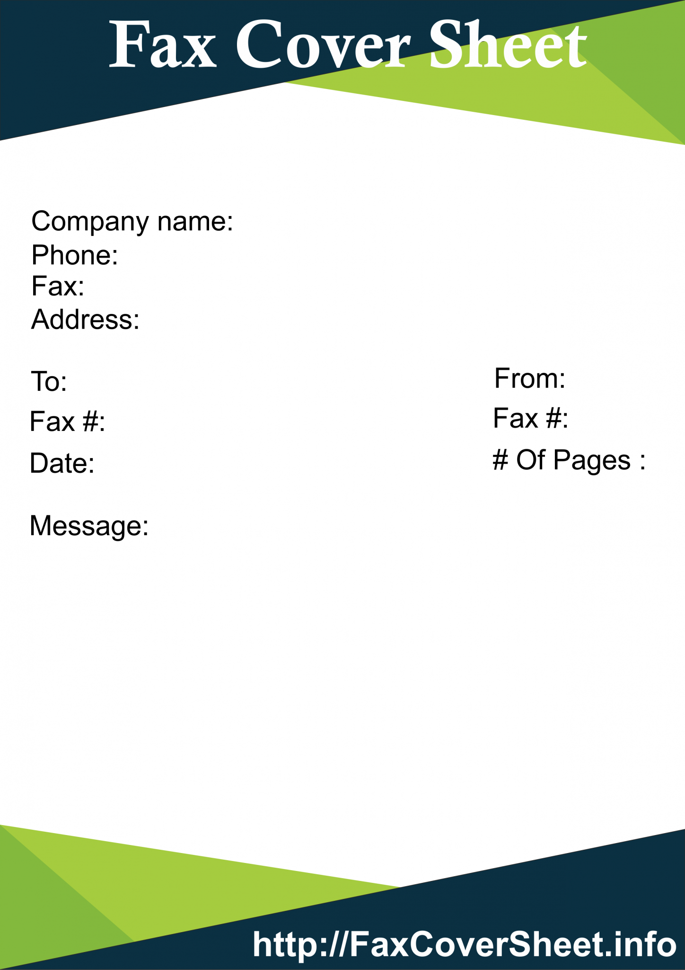
Sample Fax
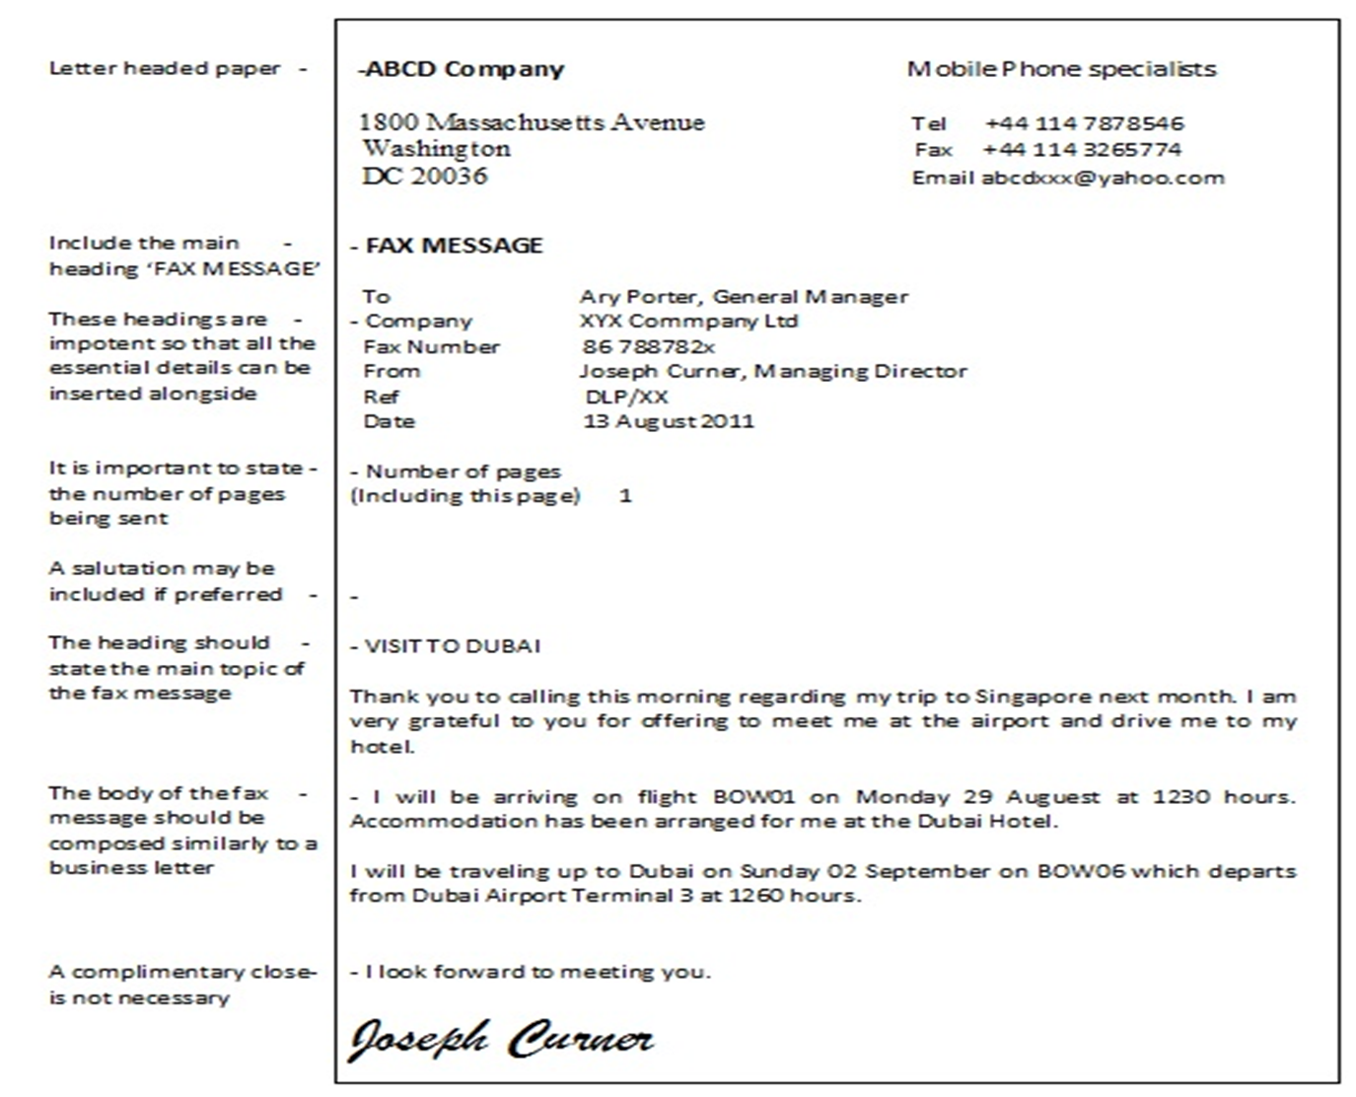

Essay writing
Essay is derived from the French word essayer, which means “to attempt,” or “to try.”
An essay is a piece of composition or writing based on a single subject matter, and often gives the personal opinion of the author.
“a literary device for saying almost everything about almost anything.”
“a short piece of writing on a particular subject.”
"a short piece of writing that expresses information as well as the writer's opinion.”
The three major parts of an essay are introduction, body, and conclusion.
The introduction - This is where the subject or topic is introduced. You state the main idea and introduce the key points briefly here.
The body - All the main points are discussed here in detail. You provide all the evidence or support you can for your essay topic.
The conclusion - The last part of an essay and usually summarizes the overall topic or ideas.

Types of essays
There are five main types of essay: descriptive, expository, narrative, persuasive and argumentative. Each has a specific focus.
Descriptive Essay - The purpose of a descriptive essay is to describe something. The object of definition can be a person, a place, a thing, or an idea.
Expository Essay - The purpose of this type of essay is to explain something. It may have description, narration, and persuasion in it, but the main purpose of the essay is to explain.
Narrative Essay - The purpose of a narrative essay is to tell a story. It will have a beginning, a middle, and an end. It may have description and exposition (explanation), but basically, it will tell a story.
Persuasive Essay – The purpose of a persuasive essay is to convince the readers to agree with the writer by using emotions, personal ideas, etc.
Argumentative Essay – The purpose of an argumentative essay is to convince the readers to accept the writer’s idea as true, by using statistics, facts and figures, etc.

Module - V: Writing Skills
Characteristics of writing
The following are some of the general characteristics of writing.
Clarity and focus: In good writing, everything makes sense and readers don’t get lost or have to reread passages to figure out what’s going on. Focused writing sticks with the plot or core idea without running off on too many tangents.
Organization: A well organized piece of writing is not only clear, it’s presented in a way that is logical and aesthetically pleasing. You can tell non-linear stories or place your thesis at the end of an essay and get away with it as long as your scenes or ideas are well ordered.
Ideas and themes: Is the topic of your paper relevant? Does your story come complete with themes? Can the reader visualize your poem? For a piece of writing to be considered well crafted, it has to contain clearly identifiable ideas and themes.
Voice: This is what sets you apart from all other writers. It’s your unique way of stringing words together, formulating ideas, and relating scenes or images to the reader. In any piece of writing, the voice should be consistent and identifiable.
Language (word choice): We writers can never underestimate or fail to appreciate our most valuable tools: words. Good writing includes precise and accurate word choices and well crafted sentences.
Grammar and style: Many writers would wish this one away, but for a piece of writing to be considered good (let alone great), it has to follow the rules of grammar (and break those rules only when there’s a good reason). Style is also important in ensuring that a piece of writing is clear and consistent. Make sure you keep a grammar book and style guide handy.
Credibility or believability: Nothing says bad writing like getting the facts wrong or misrepresenting oneself. In fiction, the story must be believable (even if it’s impossible), and in nonfiction, accurate research can make or break a writer.
Thought-provoking or emotionally inspiring: Perhaps the most important quality of good writing is how the reader responds to it. Does she come away with a fresh perspective and new ideas? Does he close the cover with tears in his eyes or a sense of victory? How readers react to your work will fully determine your success as a writer.
To write well, a writer must be able to recognize quality in a piece of writing.
Writing is also an art form and therefore subject to personal taste. Can you read a book and dislike it but acknowledge that the writing was good? Have you ever read a book and loved the story but felt that the writing was weak?
A writer should be able to articulate why a piece of writing succeeds or fails, and a writer should also be able to recognize the qualities in a piece of writing even when it doesn’t appeal to personal taste. These skills are especially necessary when writers are reviewing or critiquing other writers’ work and when revising, editing, and proofreading their own work.

Mechanics of writing
Mechanics of writing constitute the following elements. All writers should practice to write better by paying attention to the following.
Grammar
Sentence structures
Phrases and Clauses
Verb tenses
Concord
Parts of speech
Punctuation
Comma Rules
Semicolon Rules
The Colon, the Dash, and the Ellipses
Capitalization and Number Usage
Quotation Marks, Apostrophes, and Hyphens
Similar Words and Spelling Tips
Editing Tips and Proofreading Practice
Circular Writing
A circular is a tool of official internal communication in most organizations.
Circulars facilitate communication among the employees in every organization, irrespective of their size.
Internal communication in an organization between superiors and employees, between departments, amongst the department is one of the keys to success.
A circular is essentially a letter containing some important information that is distributed to a large number of people. For instance, a circular is sent to invite an entire department for a meeting, or update the dress policy for the whole office.
Benefits of Circulars
Precise and effective way of communication
Quick and cost-effective way of communication
Time-saving, circulars reach a large number of people in very limited time and effort
Advertising and marketing tools as well - can help create a new market, educate people about the product or services and also increase consumer confidence in the company and the product
Sample circulars
Circular No. 14A
25th October 2018
Revised Working Hours
All Employees of BrainTrain,
This is to inform all employees there will be a change in the working hours of the organization effective immediately. As you know we now do not function on any Saturdays. So we only have 5 working days in a week. Therefore, a revision in the working hours was necessary to ensure the quality of work does not suffer. Hence, one hour will be added to the previous 9 hour work days. The revised working hour will be as follows:
Working Days: Monday to Friday (except holidays)
Working Hours: 8:30 am to 6:30 pm (These hours will include the one-hour lunch break)
All employees are requested to note these new and revised timings. The timings are effective immediately from 26 October 2018. Punctuality and adherence to the new timings are requested. Repeated defaulters will face action. Please contact the HR department or your managers for any queries you may have.
Gargi,
CEO, BrainTrain
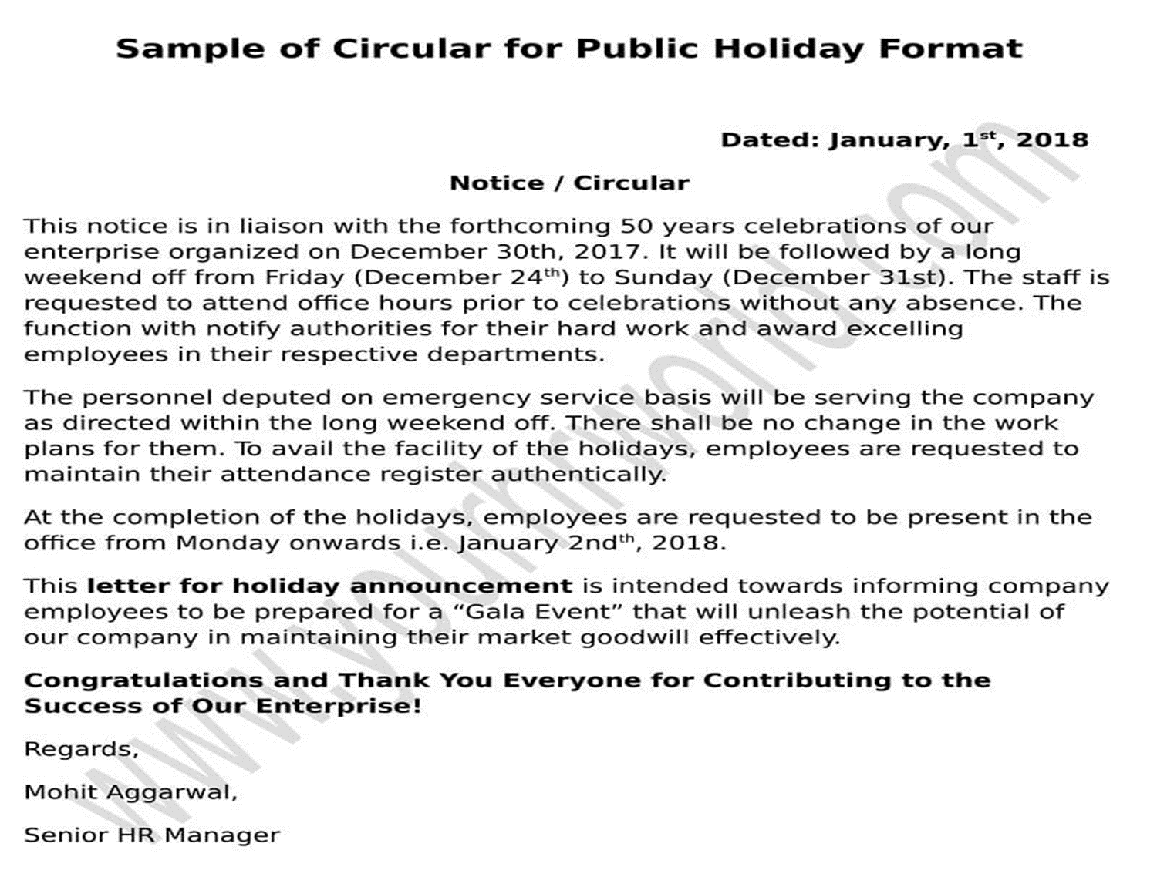

Memo Writing
Business memorandum or memoranda — also called memo or memos — are specially formatted written communications within a business organization.
A memo’s format is typically informal (but still all-business) and public.
Memos typically make announcements, discuss procedures, report on company activities, and disseminate employee information. If you have something confidential to communicate, don’t do it in a memo.
The tone of memos usually is informal and friendly with a certain succinctness. However, the tone need not be curt, officious, or patronizing.
Structure the memo so that the most important information comes in the first paragraph and that subsequent paragraphs spell out what’s discussed in the first paragraph.
Memo structure
An addressee: Flush left, in capital letters, near the top of the page
The sender: Flush left, in caps, immediately below the addressee
Date: Flush left, in caps, immediately below the sender’s name
Subject: Flush left, in caps, immediately below the date
About Flush left
In English and most European languages where words are read left-to-right, text is usually aligned "flush left", meaning that the text of a paragraph is aligned on the left-hand side with the right-hand side ragged. This is the default style of text alignment on the World Wide Web for left-to-right text.

Sample memos

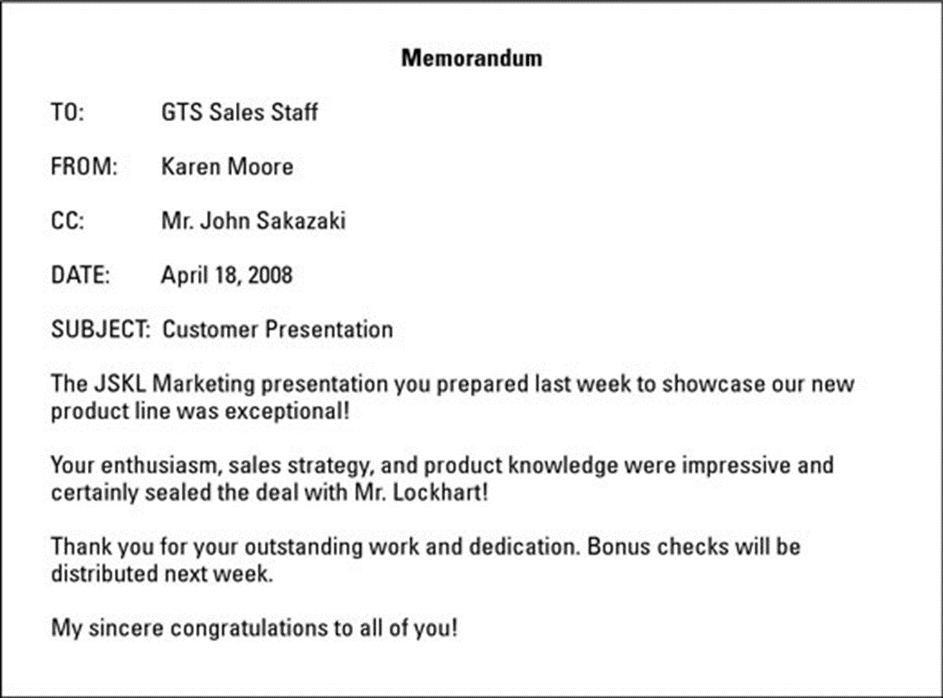

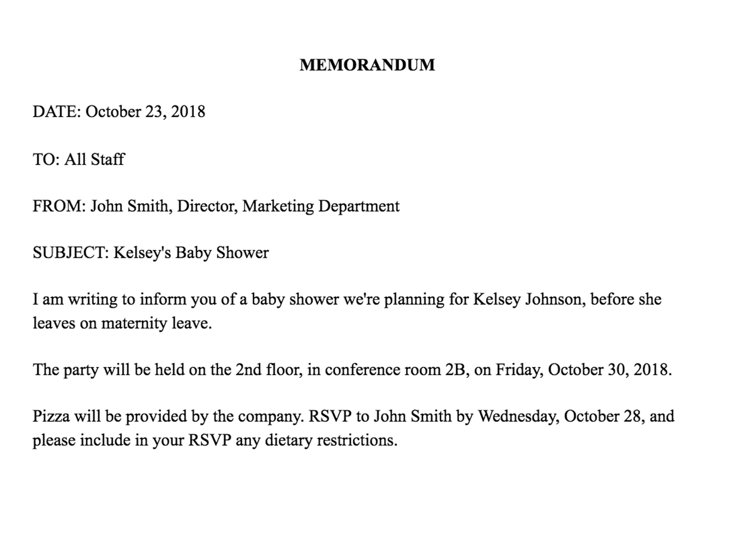

Report Writing
A report is a written account of a situation, event, project or process.
Examples of reports:
a paper a student writes about an event
a summary of findings provided after a committee investigates a situation
a teacher's description of student behavior at a conference
A report
is written in a formal style
has an introduction, body and conclusion
shows analytical thinking/reasoning ability
research information and present evidence to support a conclusion
Reports are divided into sections with headings and subheadings.
Reports can be academic, technical or business related, and feature recommendations for specific actions.
Reports are written to present facts about a situation, project or process and will define and analyze the issue at hand.
Reports relay observations to a specific audience in a clear and concise style.
Report format
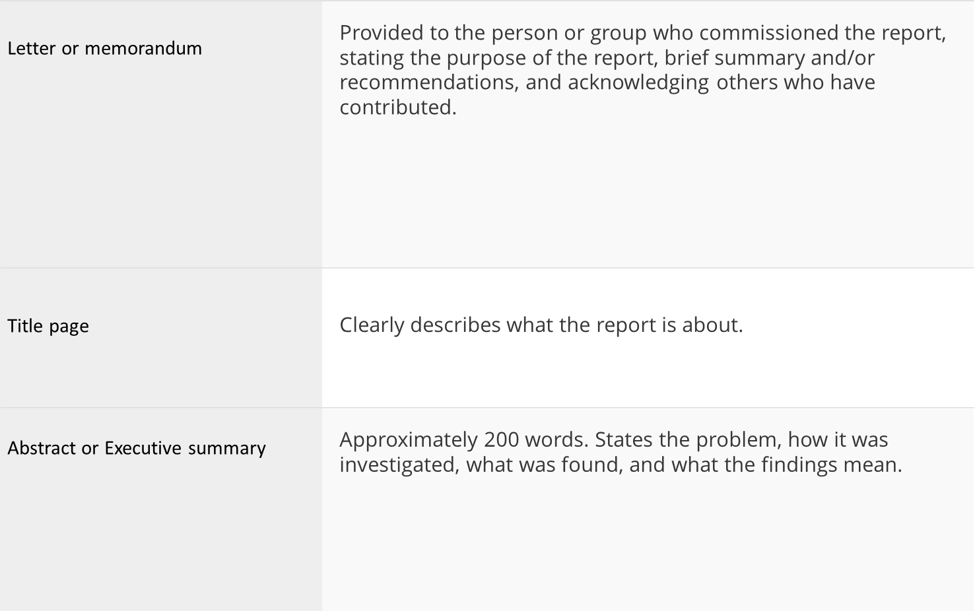

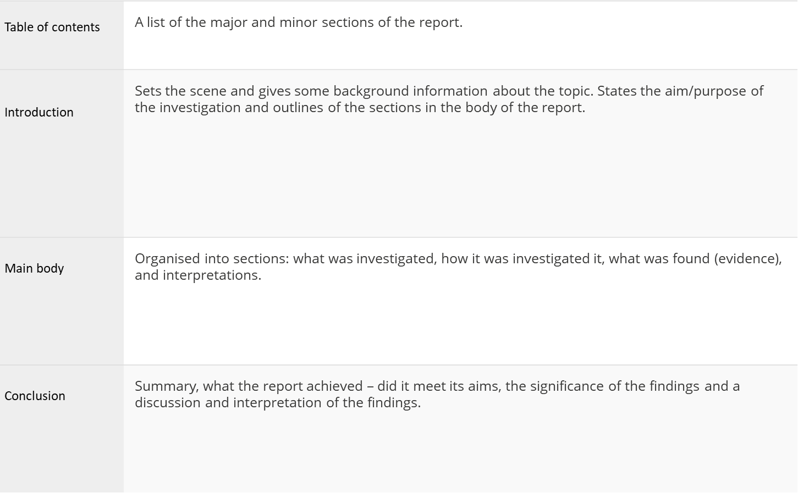
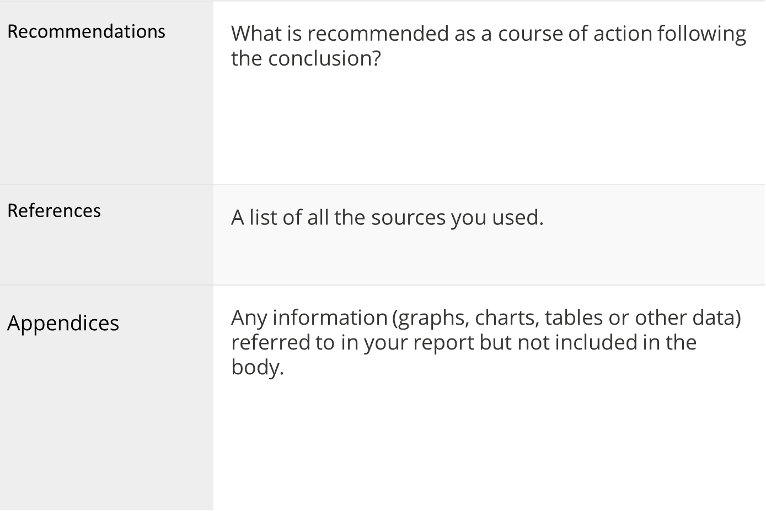

Sample work report

November 5, 20XX
Prepared by: Sally Smith
ABC Company

This report is to provide an update on the XYZ project that is due on December 5th. This project will result in the creation of a new employee handbook that will include updated rules and regulations as well as the approved increase of paid-time-off. This handbook will work to increase employee awareness of workplace expectations as well as inform them of the new benefits that have recently been implemented.
Summary of work completed:
As of this date, I have completed the following for the XYZ project:
Verified all information that will be in the handbook with upper management and HR
Drafted a table of contents
Formatted layout of handbook
Composed the first 12 pages of handbook
Tasks to be accomplished by November 12, 20XX:

Compose five more pages of handbook.
Proofread and edit all pages that have been completed up to this date.
Have the manager of HR read handbook content to ensure accuracy.

Conclusion

The XYZ project is on track to be completed by the scheduled date. This project currently has no obvious obstacles or issues, but if they should arise they will be promptly addressed.

SOP
A Statement of Purpose, also referred to as an SOP, is an essay that portrays/highlights your academic achievements and personality to the admission committee for getting enrolled in universities abroad.
Sample SOP
STATEMENT OF PURPOSE
MS in Computer Science
I consider that one should look for opportunities to further enhance one’s strengths. Software Engineering is a field which allows me to upgrade with the latest technology from time to time. I have been a keen observer and have always learned things rather quickly. These qualities enable me to adapt to any kind of changes and challenges. I would love to excel in areas associated with software technology to propel my academic and research journey. My career objective is to learn new things continuously and to improve my knowledge and skills of the field of computer science by opting for MS in Computer Science.

During high school, my interest in logic-oriented subjects drove me to take Mathematics, Physics, and Chemistry as my major subjects. When I was in the eleventh grade, I got my first personal computer and my liking for video games made me wonder about the technology behind these games. Ever since then I grew rapidly interested in computers. I did my schooling from the Pragathi Vidyaniketan School and my graduation from the Jawaharlal Nehru Technological University Hyderabad with an aggregate of 85%. Since my school days, the ever-growing IT industry has always amazed me. I was surprised to learn how a computer program is converted into binary digits and how these inputs are computed to get the desired output. This got me keenly interested in learning about the concepts of IT field. I worked hard to secure a place for me in the top most engineering college of my city, JNTU Hyderabad. Though I studied in the Electrical department, it didn't deter my strong aspiration to continue my journey in the CS industry and I have put in all efforts to acquire concepts to excel in it. Maintaining a healthy aggregate in my branch of study in college, pursuing courses like Digital Signal Processing and Microprocessors and Microcontrollers enabled me to understand how the concepts of computers are applied to practical systems in day-to-day life.
Wishing to explore this ever-growing field, I took up a course in the Google Cloud Platform. Learning about the functionality of all the relevant services that we use on a daily basis was my first step towards understanding the real world technologies. Concepts related to the Neural Networks got me intrigued in it big time when I had it as a core subject in my college curriculum. I followed up this desire and researched on this subject by enrolling myself in various courses that dealt with the real-time applications of the Neural Networks. The courses on Neural Networks and Deep Learning familiarized me with the basics concerning Neural Networks and helped me to explore a number of other sources of study to understand them better. I also did a course in Convolution Neural Networks which made me realize how engulfed we are in a world involving applications of all of these concepts. The fascinating nature of the concepts of IT industry provided me a huge impetus to take up a course Google IT Support Specialization and go over with the technicalities revolving around it such as Computer Networks, Operating Systems. These courses gave me a sneak-peek into a future with unthinkable possibilities.
To fulfill a requirement of the senior year of undergraduate program, I worked on a project with a government organization known as DRDL (Defense Research & Development Laboratory) and as a part of this project my team and I worked on “Development & Qualification Testing of On-Board Devices” in 2018. This experience made me aware of new technologies and how to apply those in real-world scenarios. My dedication and interest in the subjects helped me to have a strong base on academics.
To boost my career interest, I successfully completed a training program in “Artificial Intelligence with Python & IBM Watson” in 2019 and even worked as a project trainee at “Sumfive Technologies Pvt Ltd” from December 2019 to June 2020. Given my participation in above projects, I am highly confident that a I am sufficiently suited to pursue my career in the software field.
Overall, I’m fully inclined to pursue higher studies in the academic area of my choice involving research, thereby gaining a comprehensive knowledge in my field. Masters in Computer Science is one of the rapidly emerging fields. Technology is updated rapidly and storage of data is automated with easy access. To keep up with the advancements in this field, I would like to enhance my skills by pursuing a master in Computer Science program. To upgrade the knowledge of keen enthusiasts of latest innovations and technologies such as me, American universities, I consider are the best places. The academic and research culture of U.S.A, I am understood, allows for innovation and freedom coupled with the state-of-the-art infrastructure. Attending your prestigious university for MS Program in Computer Science would be the perfect launch pad for my aspirations and it would also be an honor to study under a pool of your well-informed and accomplished faculty. Hoping that my application merits your due consideration, I wish to be considered for admission into M.S program of your esteemed university with financial assistance.

ELS Syllabus

2020-21 Onwards  (MR-20) | MALLA REDDY ENGINEERING COLLEGE  (Autonomous) | B. Tech.  V / VI Semester
Code: | ENGLISH LANGUAGE SKILLS  (Open Elective)  (Common for CE, EEE, ME, ECE, CSE, IT and Min.E) | L | T | P
Credits: 3 |  | 3 | - | -

Course Objectives:

The course aims to enrich students’ English language skills through lessons on the latest topics in the business world and to upgrade the learners’ communication and presentation skills and to enable the students to communicate at an advanced level. This course also aims to groom the learners’ personality and make them self-confident individuals by mastering inter-personal skills, team management skills, and leadership skills by giving hands-on experience about business presentations and attending team meetings. The course also enhances students’ overall communication skills and soft skills, keeping in view changing job market trends and industry requirements.

Module – I: Communication Skills [10 Periods]

Types of Communication-Oral, aural and written, Reading-Word Power-Vocabulary-Technical Vocabulary, Rate of speech- pitch, tone-clarity of voice.

Module – II: Conversation Skills [10 Periods]

Informal and Formal conversation, Verbal and Non - verbal communication. Barriers to effective communication - Kinesics

Module – III: Reading Skills [10 Periods]

Types of reading–reading for facts, guessing meaning from context, strategies of reading- scanning, skimming, inferring meaning, critical reading.

Module – IV: Creative Writing [10 Periods]

Letter-writing-business letters-pro forma culture-format-style-effectiveness, promptness-Analysis of sample letters collected from industry-email, fax, Essay writing-nuances of essay writing, types of essays

Module - V: Writing Skills [10 Periods]

Characteristics of writing – mechanics of writing – methodology of writing – format & style- structures of writing – circular writing – memo writing – instructions writing, Report Writing, SOP.

Reference Books:

- Rajendra Pal S Korlaha, Essentials of Business Communication, Hi: Sultan Chand & Sons, New Delhi.
- Andrew J. Rutherford, Basic Communication Skills for Technology,: Pearson Education Asia, Patparganj, New Delhi-92.
- V. Prasad, Advanced Communication skills, Atma Ram Publications, and New Delhi.
- Raymond V. Lesikav; John D.Pettit Jr.; Business Communication: Theory & Application, All India Traveler Bookseller, New Delhi-51
- R K Madhukar, Business Communication, Vikas Publishing House Pvt Ltd

E Resources
- https://blog.udemy.com/types-of-communication/ (Communication Skills )
- https://www.skillsyouneed.com/ips/conversational-skills.html (Conversation Skills)
- http://lrs.ed.uiuc.edu/students/jblanton/read/readingdef.htm (Reading Skills)
- https://www.thoughtco.com/what-is-composition-english-1689893 (Writing and composition )

Journals/Magazines links
- http://www.mansfield.edu/fye/upload/Academic-Reading-Skills.pdf (Reading Skills)
- http://www.journals.aiac.org.au/index.php/IJALEL/article/view/2471 (Writing Skills)

NPTEL VIDEOS:
- https://www.youtube.com/watch?v=cQruENyLNYI&list=PLbMVogVj5nJSZB8BV29_sPwwkzMTYXpaH (Communication Skills)
- https://www.youtube.com/watch?v=p1-etClsXdk&index=5&list=PLbMVogVj5nJSZB8BV29_sPwwkzMTYXpaH (Conversation Skills)
Course Outcomes:
After completion of the course, students will be able to:
- Understand the importance of various forms of non-verbal communication.
- Participate confidently in business meetings.
- Gain an understanding about different types of reading skills and employ the same during competitive exams.
- Recognize the importance of writing in real time situations.
- Improve the skills necessary to meet the challenge of using English in the business world.

